Ebenezer Edbert Newton

Known that he was b Ludham 1860 son of Robert and Elizabeth.(Betsey).
Died 1869

1861 he is living with his father, mother and sister and grandparents in Catfield. They have recently returned from USA where Arletta his sister was b in 1855.

1871 they are living at the Kings Arms Ludham where his father is the innkeeper.

1881 they are back in Catfield where his father is running the pub and he is a millwright:
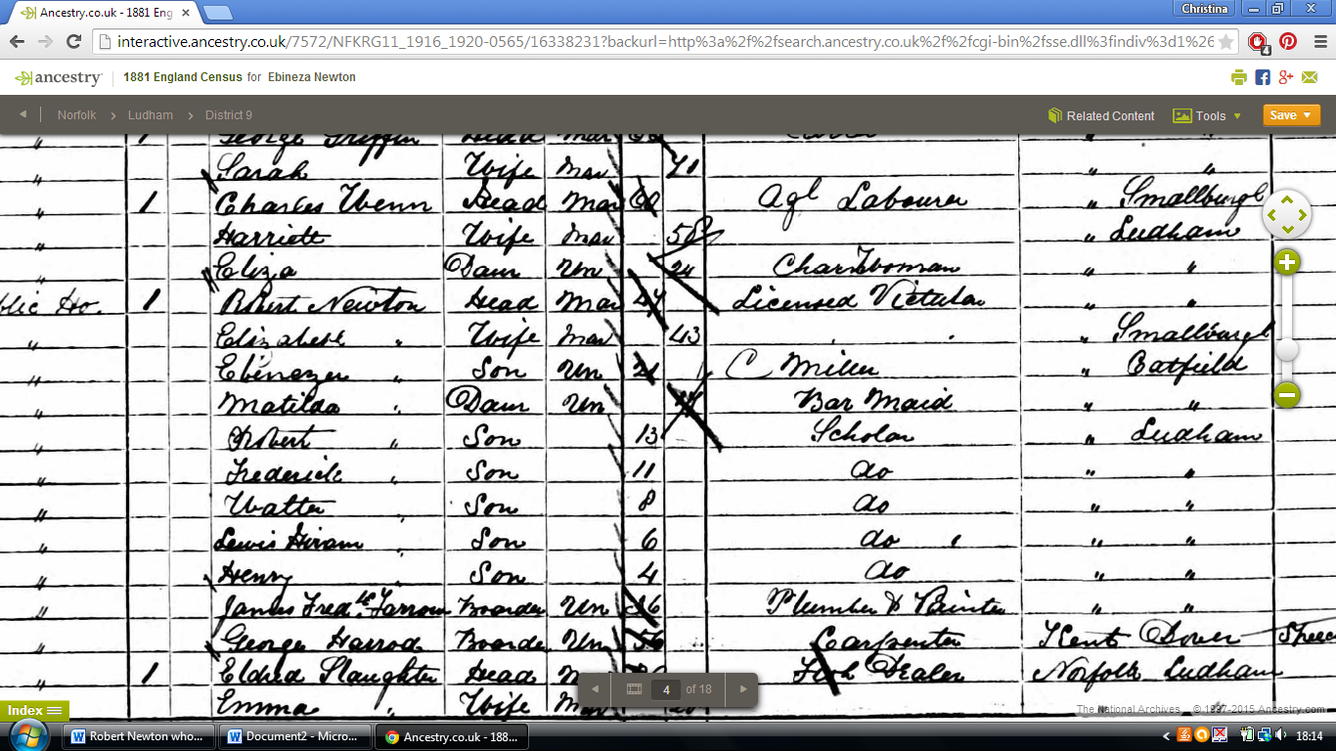
1891 they are living at Mill House on the Yarmouth Road and he is married to Ann.
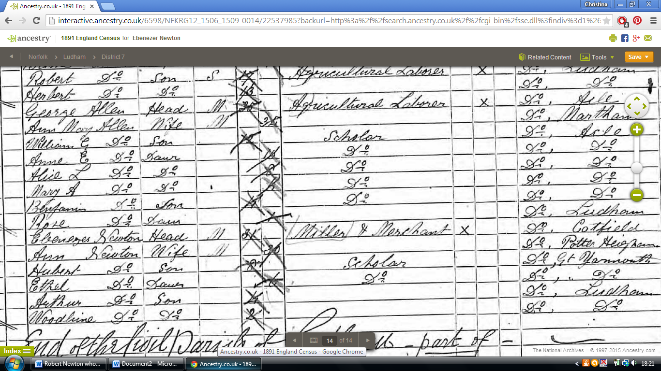

1901 same place, more children
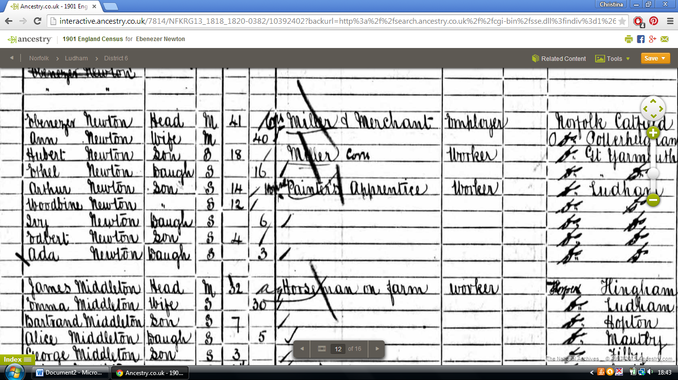
1911 although he is still married, his wife is not with him:
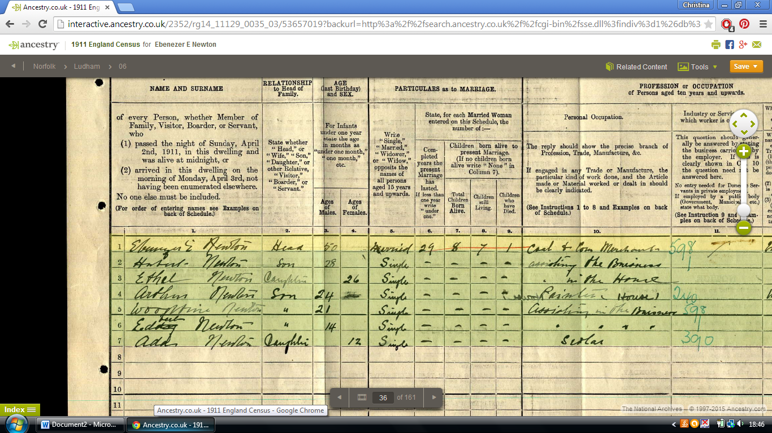
So his children were:
Ada b 1898 d 1937
Ivy b 1895
Edbert b 1897
Hubert b 1883 d 1937
Ethel b 1885 d 1966
Arthur b 1887
Woodbine b 1889 d 1960

