Walter Newton

Known that he was b Ludham 1836 and was the son of Robert Newton Jr and Susannah King. Suspect his claimed marriage to Eliza Fenn is wrong as this was in Poplar London in 1864 to a Walter Frederick Newton whose father Robert was also an innkeeper, but in Rupert Square area of Poplar. Doubtful that his death too is in 1910 South Shields, Tyneside and his wife Eliza’s death 3 years later in Washington USA.
Beulah’s family tree does have his birth as 1836 and as a child of Robert and Susannah.
Her notes also show that his baptism was in Ludham 5th June 1836.
(there is also a Walter Newton son of Robert and Elizabeth Newton baptised 2nd Feb 1873)

Birth
Name: | Walter Newton
Gender: | Male
Christening Date: | 05 Jun 1836
Christening Place: | Ludham, Norfolk, England
Father's Name: | Robert Newton
Mother's Name: | Susanna
Indexing Project (Batch) Number: I03458-5 , System Origin: England-EASy , GS Film number: 1911695 , Reference ID: 80

Marriage
Marriages Mar 1859 (>99%)

Brunswick | Isabella |  | S Shields | 10a | 573
Newton | Walter |  | S.Shields | 10a | 573

Death
Name: | Walter Newton
Estimated Birth Year: | abt 1836
Registration Year: | 1910
Registration Quarter: | Oct-Nov-Dec
Age at Death: | 74
Registration district: | South Shields
Volume: | 10a
Page: | 441
Probate
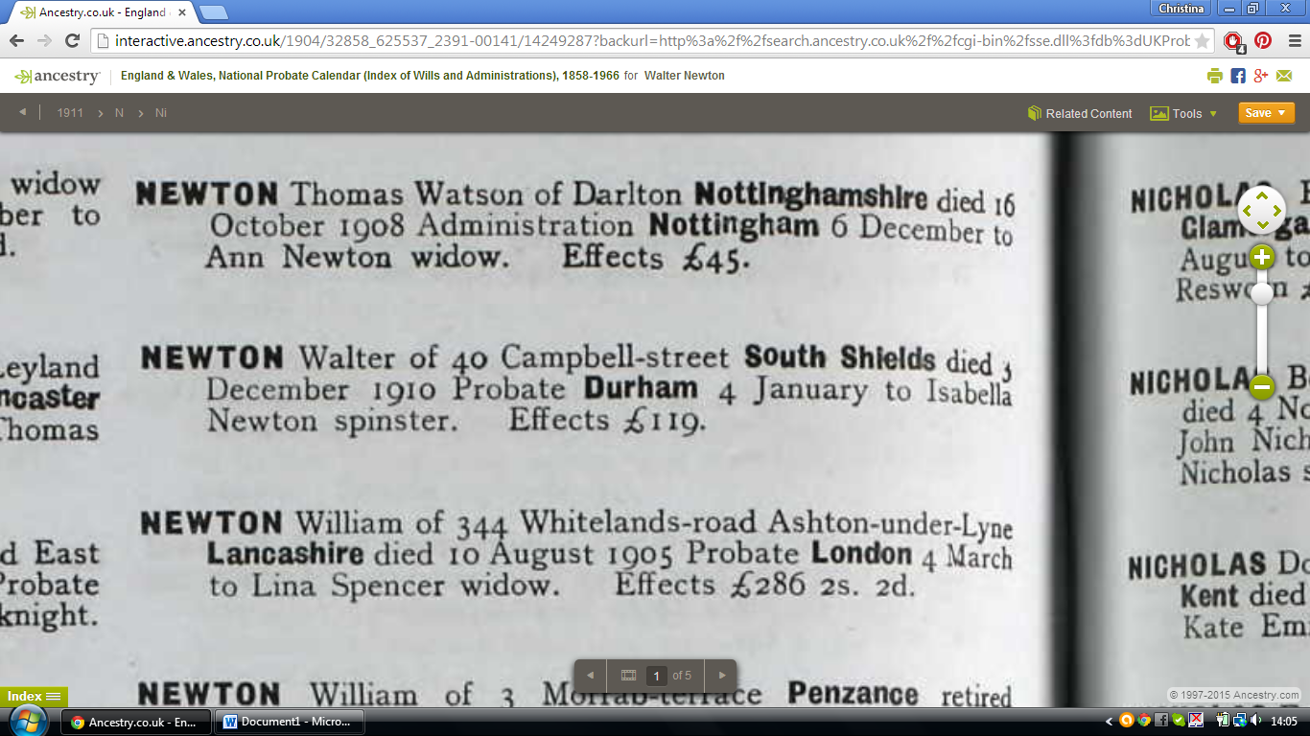
1911
Walter died in 1910, so here is Isabella as a widow living with her daughter Isabella at 315 Taylor St, South Shields:
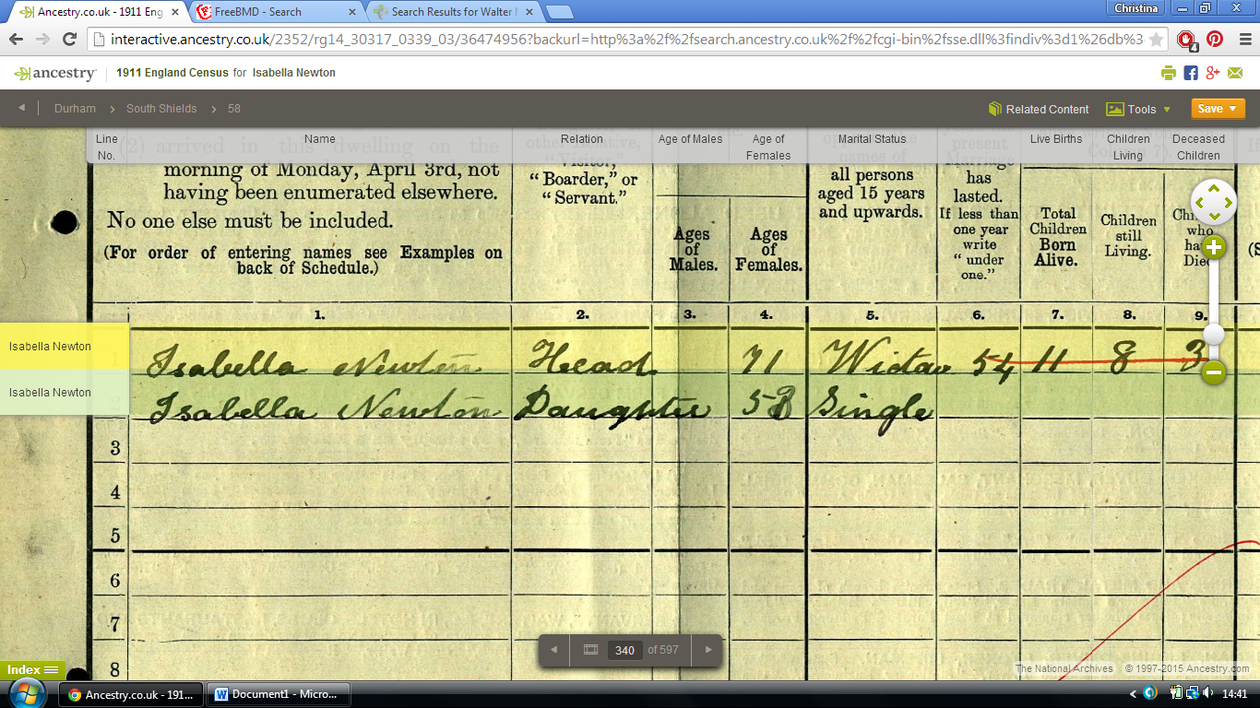

1901
Here they are living Campbell Street, Havelock Inn, South Shields:
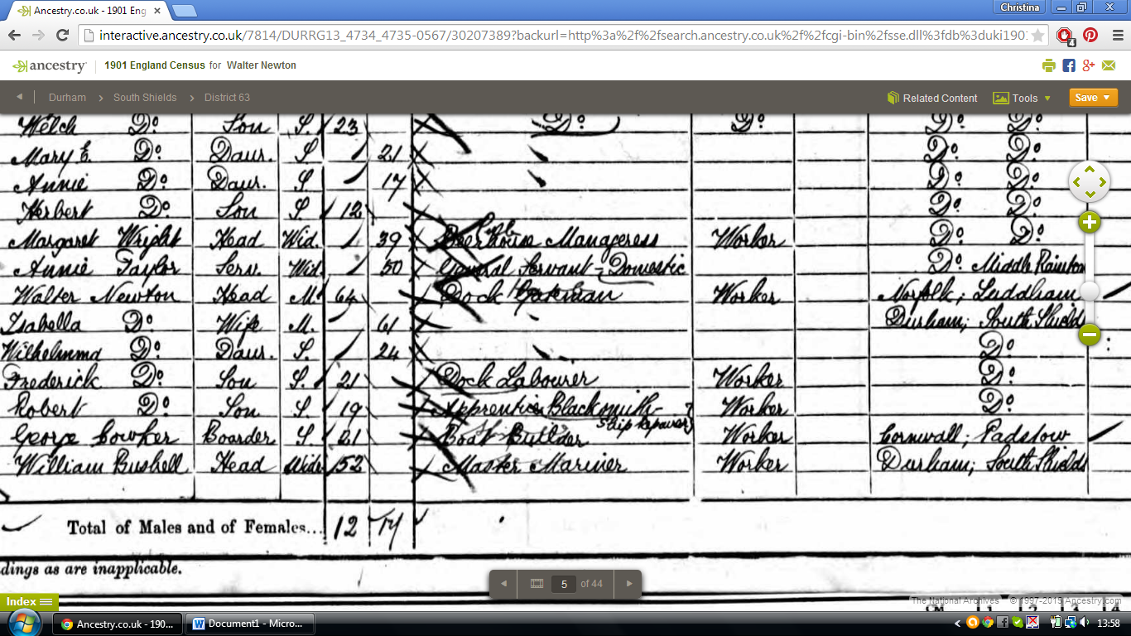
1891
Living Havelock Lane, South Shields are:
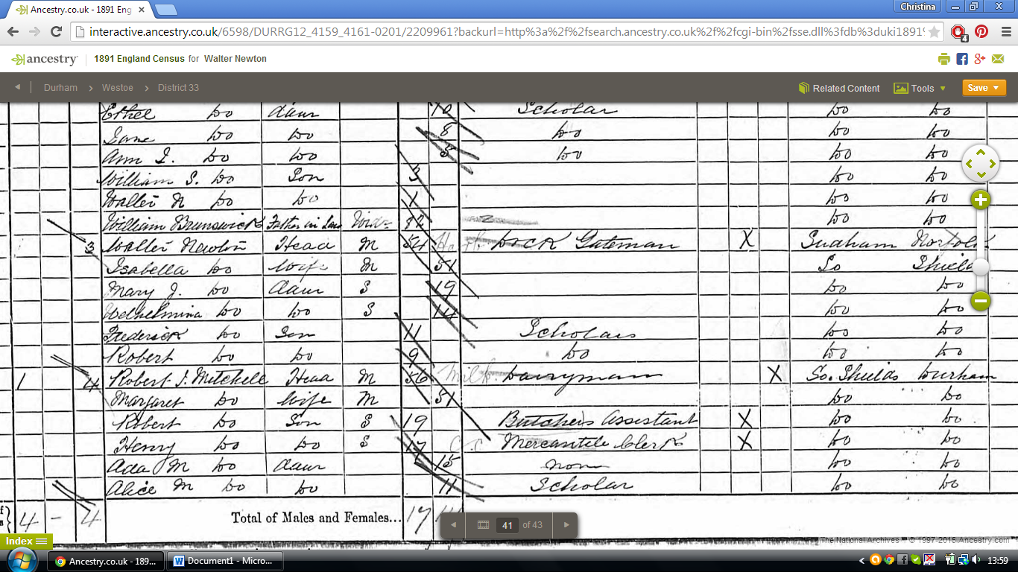

1881
Living Palmeston St, Westoe, South Shields are:

1871
Here they are living East Adelaide St South Shields with more children including a daughter named after his mother Susannah:
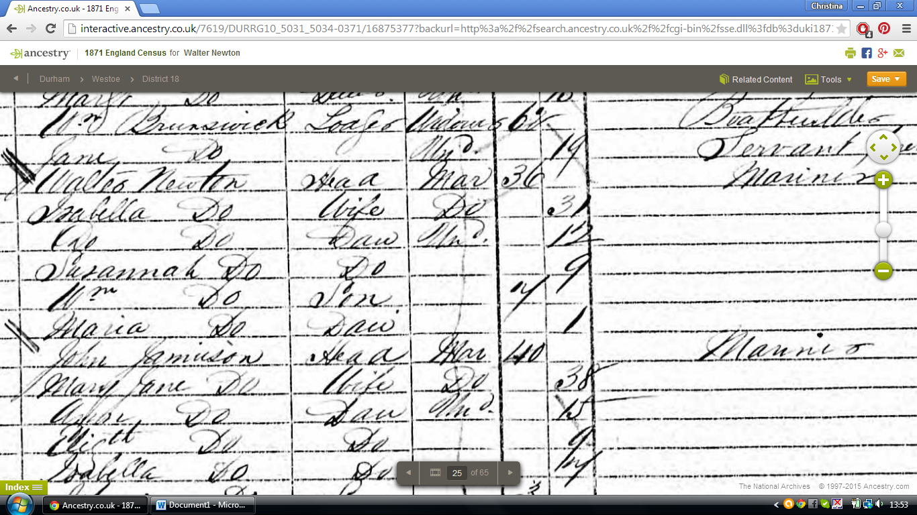

1861
Now this is a surprise, the South Shields connection is correct after all. (Found this entry first). He must have met his wife by being a sailor and sailing up the coast. Living Hill St, South Shields, County Durham are:
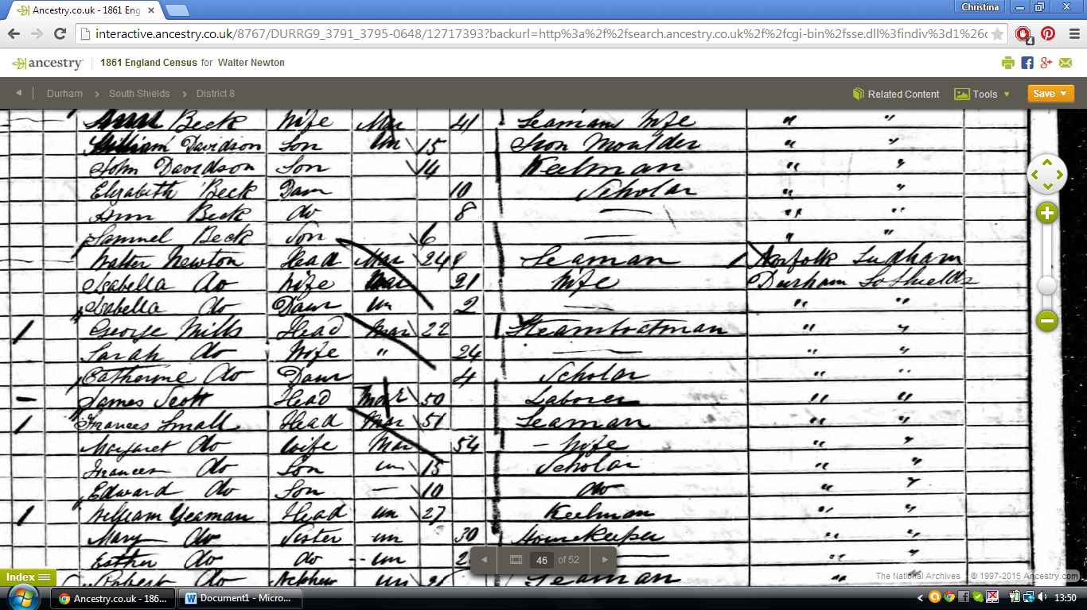

1851
Living Ludham Street, his father is an Innkeeper and postmaster are:
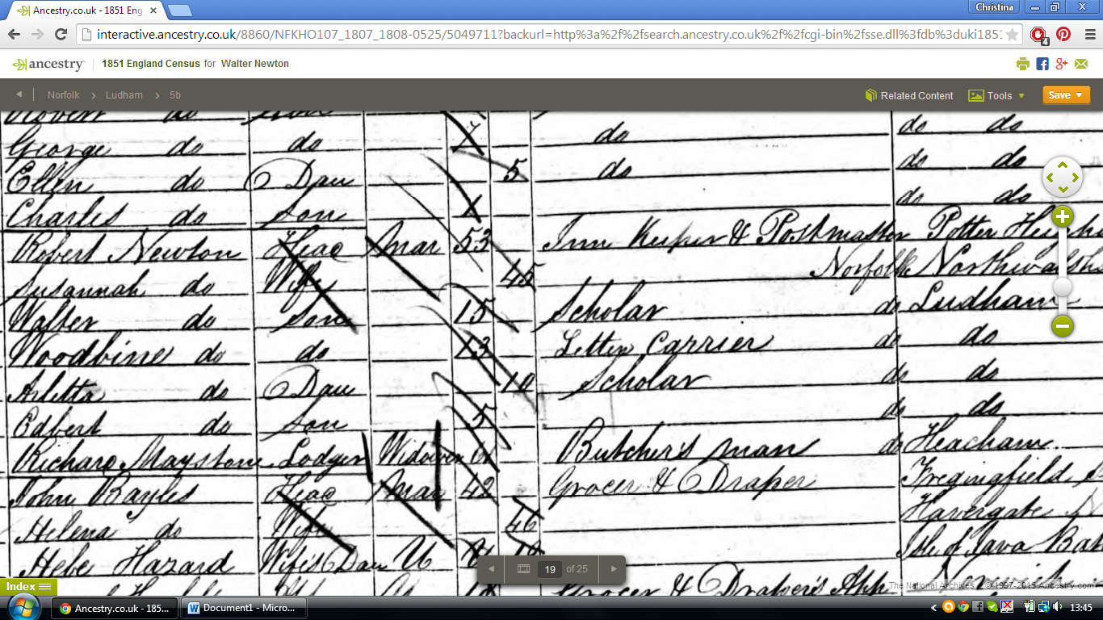

1841
Here they are living Ludham, his father Robert is an Innkeeper (probably the Rose and Crown).

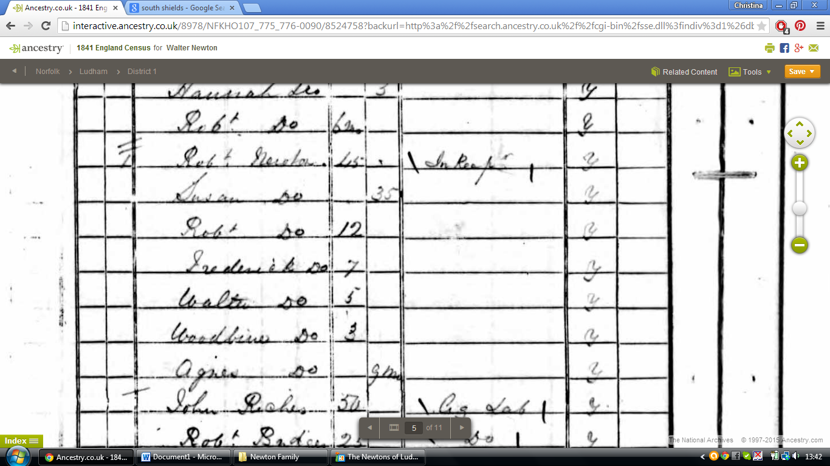

This could be Isabella’s death in South Shields:
Name: | Isabella B Newton
Estimated Birth Year: | abt 1840
Registration Year: | 1913
Registration Quarter: | Apr-May-Jun
Age at Death: | 73
Registration district: | South Shields
Volume: | 10a
Page: | 922

