Robert Newton who went to USA and came back.

Known that in the 1871 census for Ludham, he is b 1834 Ludham, the Innkeeper of the Kings Arms (not the Rose and Crown owned by another Newton). He has a wife called Elizabeth and their children are Thomas b 1866, Ebenezer b 1860, Matilda b 1862, Woodbine b 1864, Frederick b 1870, Robert b 1868 all b Ludham.

They also have a daughter called Arletta b 1855 (hard to read her age, she is a barmaid aged 14 or 16, I guess 16 is correct?). She was b Stockport, Niagara County, USA.

So in about 1855 Robert and Elizabeth must have been in USA.
I think his parents are Francis and Mary Newton of Sutton seen here with him in 1851

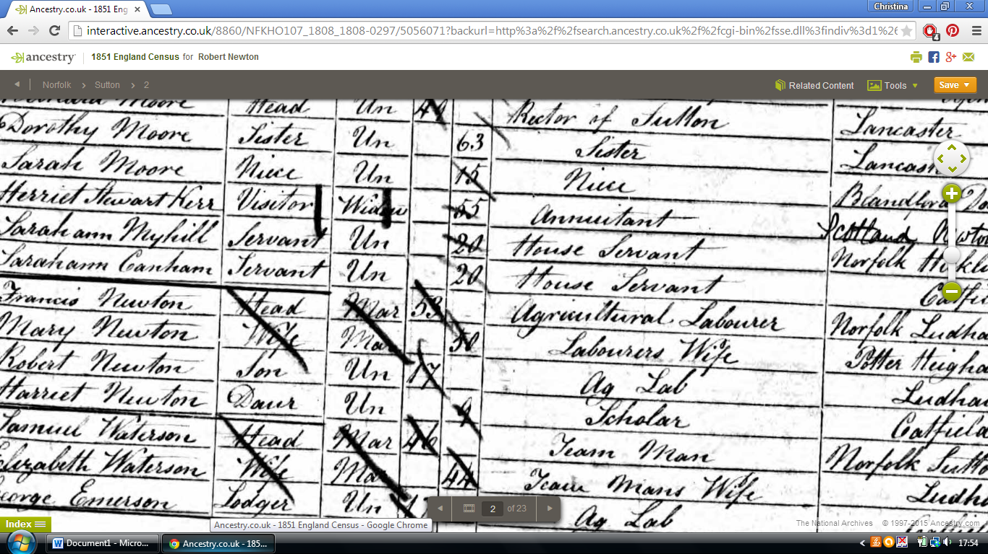
Her father was b Ludham. Searched for him in USA passenger lists but not found.

However it looks as if this is true and here is information about her:
- Birth
1857abt
Lockport Niagara County, Niagara, United States
1861Age: 4
Catfield, Norfolk, England
Relation to Head of House: Granddaughter
I think this is that census record, but she is down as Arabella not Arletta.
Her father Robert is a millwright. Ebenezer is his son but grandson of the head of House.
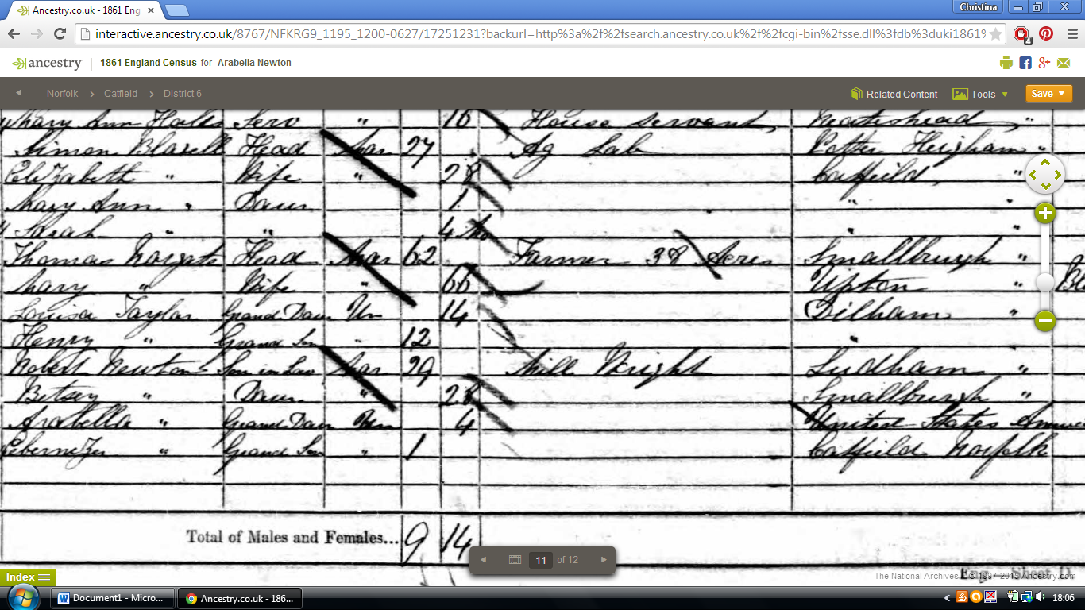
1871Age: 14
Ludham, Norfolk, England
Relation to Head of House: Daughter
Marriage to Henry Avery
18816 JunAge: 24
Holy Trinity, Newington, England
1891Age: 34
Battersea, London, England
Relation to Head of House: Wife
1901Age: 44
Battersea, London, England
Relation to Head of House: Wife
19112 AprAge: 54
Battersea, London, England
Marital Status: Married; Relation to Head of House: Wife

