Robert Newton Jr

Known that he was b Potter Heigham 1796 and married Susannah King in 1826. She was b 1806 North Walsham. Father of Walter b 1836 and many others.

Birth

Robert Newton
England, Norfolk Bishop's Transcripts
Name: | Robert Newton
Event Type: | Christening
Event Date: | 27 Oct 1793
Event Place: | Potter Heigham, Norfolk, England
Gender: | Male
Father's Name: | Robert Newton
Mother's Name: | Elizabeth Smith
GS Film Number: 1545223 , Digital Folder Number: 004005581 , Image Number: 1199
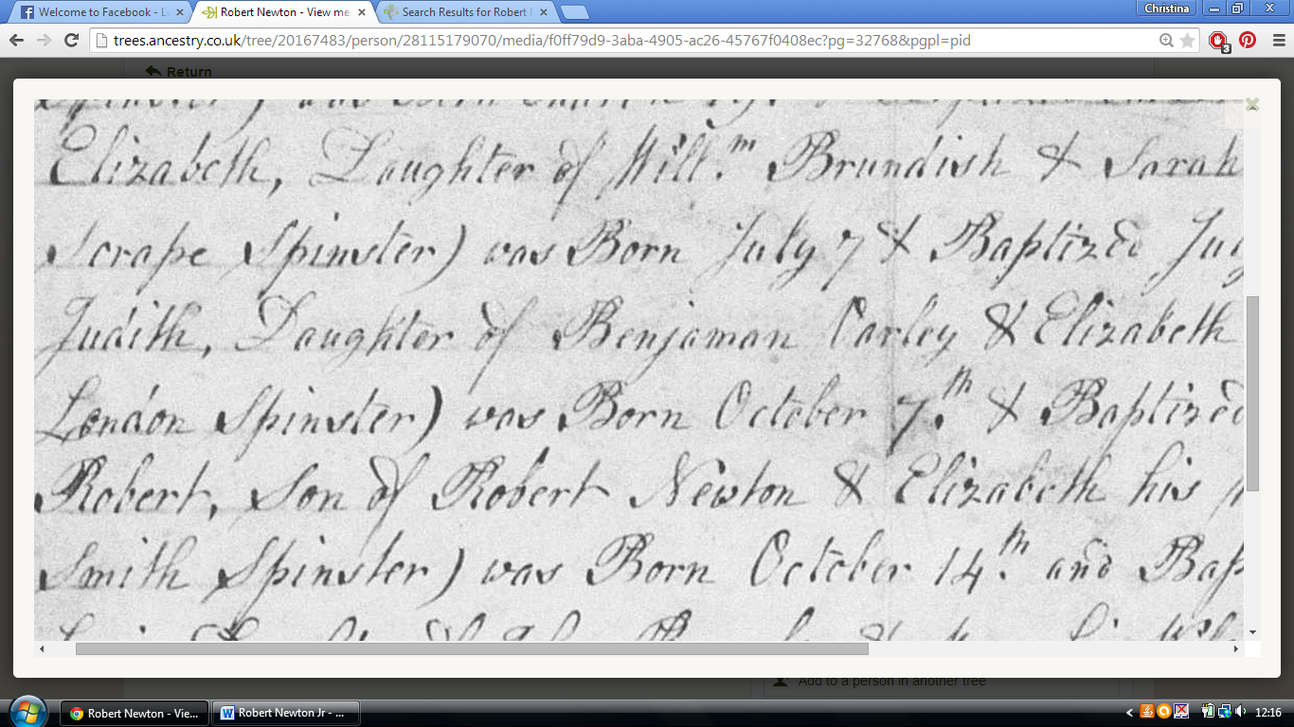
Marriage
Name: | Robert Newton
Gender: | Male
Marriage Date: | 25 May 1826
Marriage Place: | Ludham, Norfolk, England
Spouse: | Susan King
FHL Film Number: | 1911695
Reference ID: | item 8 p 25
Beulah has a copy of this parish entry. Both are single. Rev Thomas Tanqueray marries them. Witnesses are Mary Newton and Daniel Graves? Robert and Susan sign their own names.

Death
Name: | Robert Newton
Event Type: | Death
Registration Quarter: | Apr-May-Jun
Registration Year: | 1873
Registration District: | Smallburgh
County: | Norfolk
Event Place: | Smallburgh, Norfolk, England
Age (available after 1866): | 81
Birth Year (Estimated): | 1792
Volume: | 4B
Page: | 27
Line Number: | 359
Name: | Robert Newton
Gender: | Male
Burial Date: | 18 May 1873
Burial Place: | Ludham, Norfolk, England
Reference ID: item 11 p 39 , Indexing Project (Batch) Number: I03458-9 , System Origin: England-EASy , GS Film number: 1911695

1871
Here he is in his old age and widowed sharing a house with another widower on the Street in Ludham:
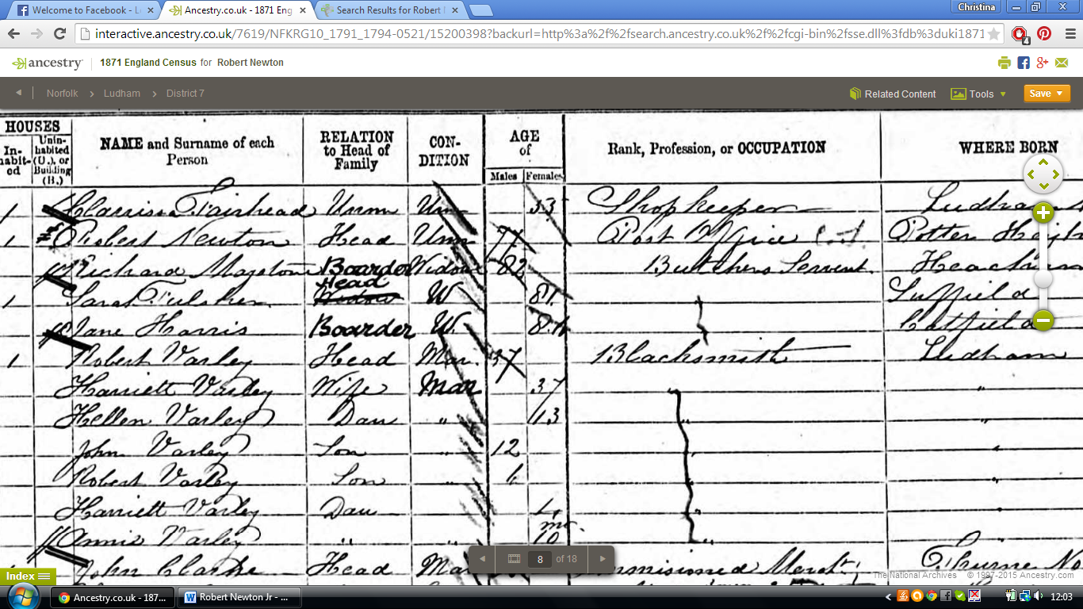
1861
Here he is as the landlord of the Crown Inn, Ludham and postmaster:
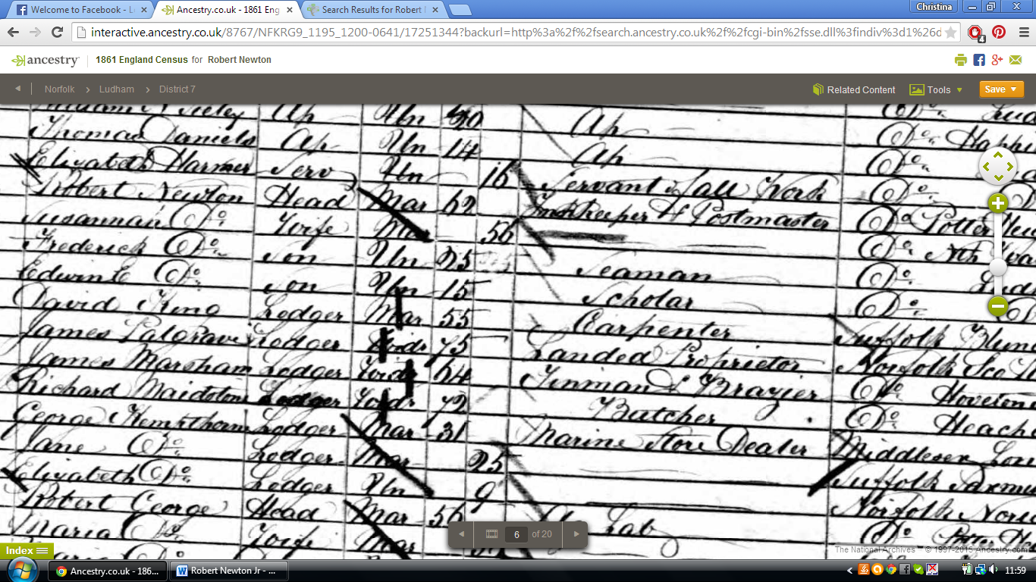
1851
Inn keeper and postmaster living Ludham, see his son’s notes
1841
Innkeeper living Ludham, see his son’s notes.

Children
Seen several copies of the following baptism records all as ‘Child of Robert Newton and Susannah’ owned by Beulah:

Edwin Edbert 29 March or 1846
Iowen Robert 17th March 1844 (Edwin?)
George Thomas 3 May 1827
Robert 4th May 1829
Agnes 10th June 1831
Agnes (again) 13th September 1840
Frederic 22nd December 1833
Walter 5th June 1836
Phebe Helen 1842

Here is an example of one of the baptisms of their children, others like this are Edwin Robert(Edbert?)1846, Hebe (Phebe?) Helen, George Thomas 1827, Adolphus Woodbine Barry 1838, Robert 1829, Louisa Robert (?) 1846, Cowin Robert 1844, Frederic(k?) 1833:
from England Births and Christenings
Name: | Agnes Arletta Newton
Gender: | Female
Christening Date: | 13 Sep 1840
Christening Place: | Ludham, Norfolk, England
Father's Name: | Robert Newton
Mother's Name: | Susannah
Indexing Project (Batch) Number: I03458-5 , System Origin: England-EASy , GS Film number: 1911695 , Reference ID: 96

I suspect some of these records have been mistranscribed, e.g. Cowin Robert may be Edwin Robert. Also there were two children called Agnes, presumably one died. The one who survived is Agnes Arletta and she is called by either name on the censuses.

Looks like at least one of their children died young:
Name: | Edwin Robert Newton
Event Type: | Burial
Event Date: | 07 Apr 1844
Event Place: | Ludham, Norfolk, England
Gender: | Male
GS Film Number: 1526654 , Digital Folder Number: 004143475 , Image Number: 227

Agnes Arletta is said to have married Thomas Skoyles b 1837 Martham and they had a daughter Arletta b 1861.

Robert Newton b 1829 is said to have married Elizabeth (Betsey) Norgate b 1833 and they had the following children:
- Arabella Newton
1857 –
- Ebenezer Newton
1860 –
- Matilda Newton
- 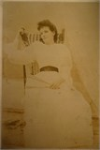
1862 – 1901 Ludham
- Woodbine Newton
- 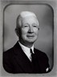
1864 Ludham – 1943 in Dallas, Collin, Texas, USA
- Thomas Newton
1866 –
- Robert Newton
1868 –
- Frederick Newton
1870 –
- Walter Newton
1873 –
- Lewis Hiram Newton
- 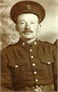
1875 Ludham – 1966 Toronto
- Henry (Harry) Newton
1877 –

Edwin Edbert b 1846 is said to have married Lois Martha Newall/Newell b 1842 White Roothing/Roding Essex and these are their children:
- John Newell Newton
1871 – 1900
- Susannah Sarah Newton
1872 –
- Lois H. Newton
1875 –
- Caroline M. Newton
1879 –
- Luther Newton
1886 –

NB Walter b 1836 DID NOT MARRY Elizabeth Fenn as suggested on some published family trees. That was Walter Frederick Newton who was born the same year in Poplar.
The Ludham Walter Newton married Isabella Brunswick, see his notes.

Other
Here he is in the Bristish Postal Service Appointment Book for 1846:
